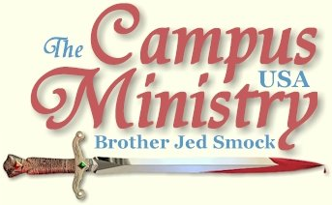
brojed@aol.com
brojed.org
573-999-0346
573-999-0346
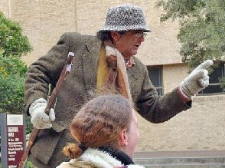

A HORSE’S HEAD OR SHOULD I SAY. . .

University of Texas, January 31, 2011

At UT we have to preach on the public sidewalk. There are a lot of students passing by and they regularly have to wait a couple of minutes at the stop light to walk across a busy street with noisy traffic. So multitudes can hear a lot of truth while they have to wait at the light.
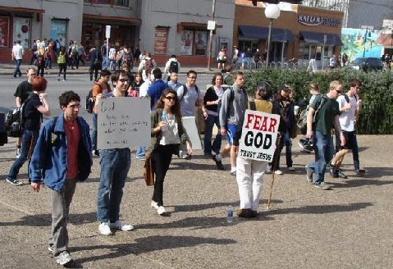
"...multitudes can hear a lot of truth while they have to wait at the light."
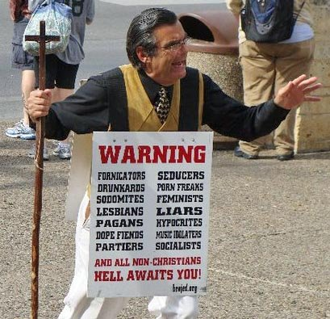

Jesse Morrell and his wife, Krista, and daughter, Elizabeth, met us on campus, driving down from Tyler, TX. I preached the noon break without gathering an audience although a few Christians vehemently opposed me for several minutes. Jesse preached at the next break holding a new banner and was able to get a few people to gather around him. Meanwhile, I was holding a warning sign listing sins a short distance from Jesse. Soon several gathered around me. Three brothers arrived from San Antonio, knowing that Jesse was going to be on campus. They were happy to see me as well. They were helpful in talking to students and asking me numerous times if I needed anything.
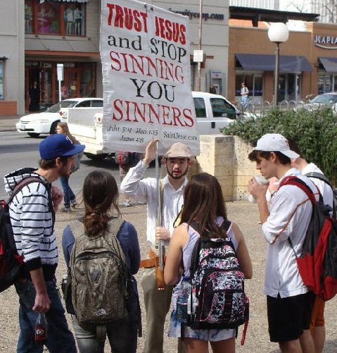
Jesse Morrell
One disgruntled Christian who opposed me earlier called the police to try to get me off campus. When three policemen came up, I was evidently across the line on University property; however, I was sitting on my stool holding my sign but not preaching. The policeman asked for my I.D. Initially, the police insisted that we needed to move across the street. We stood our ground pointing out the marker on the sidewalk which divided campus from city property. I moved behind the line and finally the police left issuing me a trespass warning. Curious about the presence of the officers, more people gathered and we ended up having a good size crowd for the rest of the afternoon which at times reached close to 100.
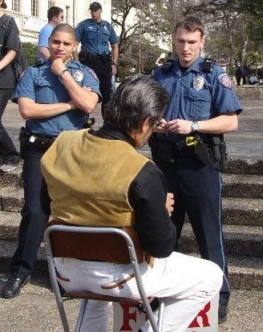
University of Texas Police ID Bro. Jed
(UT is one of the few major Universities that does not allow free speech.)
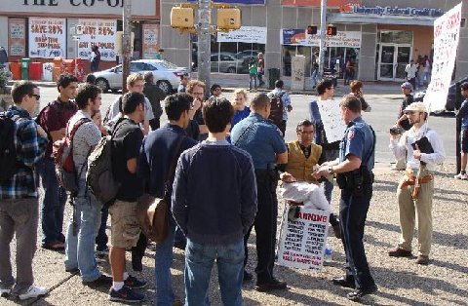
"...Curious about the presence of the officers, more people gathered and we ended up having a good size crowd ..."
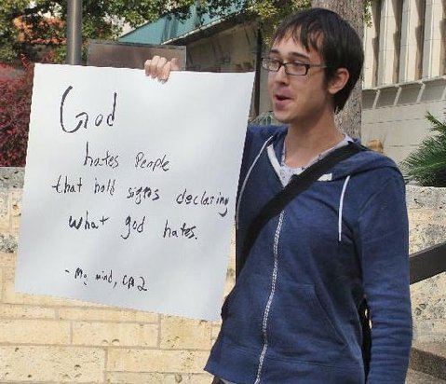

A fellow wearing a horse’s head and naked from the waist up pranced around us for 90 minutes, holding a senseless sign most of the time. Another girl who professed to be a Christian was in tears much of the time. I do not think anyone understood why she was crying. She did not like my methods or message.

UT has over the years been a campus which is better to preach on after 2 PM. The disgruntled Christian who tried to stop my preaching never had the nerve to show his face again. His attempt to prevent the students from hearing our message was counterproductive for the police presence just increased interest and even gained us the sympathy of several students. My last session was productive despite the harassment of the horse’s head, or should I say horse’s _ _ _. We preached until 5:30 PM.
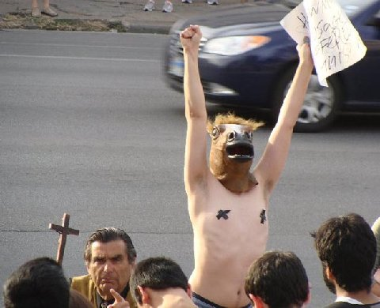
"...A fellow wearing a horse’s head and naked from the waist up pranced around us for 90 minutes..."
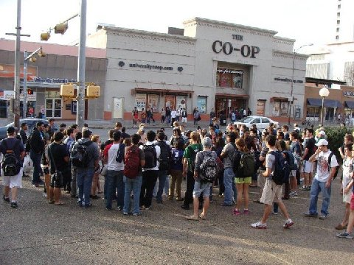

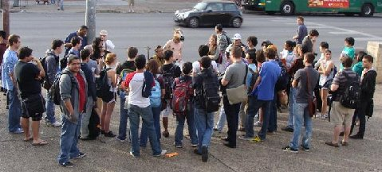
"...My last session was productive despite the harassment of the horse’s head..."

Martha took over 100 pictures today and helped Mrs. Morrell with her baby. She is expecting another one. Seeing the Morrells reminded me of Cindy and me 25 years ago. We have a good new generation of preachers of whom Jesse is a great leader.
Today it was sunny and in the 70’s. A cold wave is expected tomorrow which is predicted to continue the rest of the week.
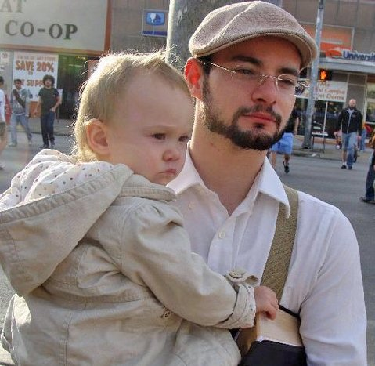
"...Jesse Morrell, his wife, Krista, and daughter, Elizabeth, met us on campus..."

“WHAT DO YOU WANT STUDENTS TO KNOW ABOUT GOD?”

Texas State University, February 1, 2011

The cold wave hit with winds up to 40 miles an hour and temperature only in the thirties. Thankfully, the sun was shining. Jesse started the meeting before the class break and he succeeded in getting students to stop. There is a good pedestrian flow on this campus. At the class break Jesse built up crowd to close to 100. Evidently, people knew I was coming for it wasn’t long before protestors arrived with their handmade signs.
The students were quite riled by the time I took my turn and they remained so throughout the afternoon. Usually I am able to quiet students down with my stories. However, I could not finish some of them since there were so many distractions. A fellow stood beside me for 15 minutes intentionally blowing cigarette smoke in my face.
Jesse and I kept hearing that we were turning people off and that we were going about it in the wrong way and that we were not wanted on campus. But the while they complained they were frozen in place.
After 4 PM we lost the sun behind a building and the temperature dropped considerably. After I dismissed the crowd at 4:30 a student wanted to record an interview with me. He asked, “What is the most important thing you want students to know about God?” A student who was listening said, “That God is love.” I replied, “Everyone says God is love. I want the students to know that God is Holy. Since God is love he always rules and reigns and behaves in a holy manner and he demands holiness from his subjects.”
As Jesse and I walked off campus, the student who said, “God is love” followed us and said, “I have asked the Lord to change me, but I do not feel that I am changed.”
I responded, “We are not to rely upon our feelings. And we must make a choice to change. God cannot change us without our cooperation and we cannot change without his influence.” I invited him to dinner with us, but he said he would return tomorrow to listen to more of what we had to say.
Kyle drove up from San Antonio to join us. Over dinner I asked him how he got involved in open air preaching. He said he heard me when he was an undergraduate at Sam Houston State. He has been in the ministry for three years.
It was the coldest day of preaching that I remember since Bro Cope and I preached in Oklahoma in December of 2009. The cold weather is predicted to be with us the rest of the week. We have our way of heating things up with the fires of the Holy Ghost radiating from us. Back home in Missouri there is a blizzard. Jesus compared the movement of the Holy Spirit to the wind. We also had blizzard conditions at Texas State, without the snow, which was brought upon by us blowing the Holy Spirit upon the campus.
Martha stayed back at the hotel with Mrs. Morrell and helped with the baby.

HISTORICAL FREEZE DOESN’T PUT OUT OUR FIRE

Texas State University, February 2, 2011,

The news says that a historical freeze has hit this part of Texas. Today was colder than yesterday and with no sun. The wind gusts were up to 30 miles. I wore six layers of clothes. We arrived on campus only to learn that afternoon classes had been canceled to conserve energy. We do not have to be concerned about conserving energy because God has an endless supply of oil to keep our lamps burning. I was not about to cancel my class in Christianity 101. Jesse managed to get up to 20 students to stop. Several others gathered around me as he preached.
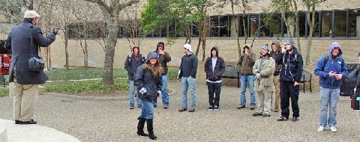
"...afternoon classes had been canceled to conserve energy..."
Shortly after Jesse turned the meeting over to me, one of these green men (wearing a full body spandex suit) came out and danced in a provocative and lewd manner around me getting as close as he possibly could without touching me. He continued through much of Jesse’s second stint. Most campuses I go to over the last year it seems like I have to deal with one of these green men. Though Jesse said it was his first experience. Most of them must be queers the way they usually dance in such a lewd fashion.
I could handle the cold as long as I was preaching but waiting on the sidelines while Jesse was preaching I was literally shaking. I did go inside for a while and monitored the scene from a window.
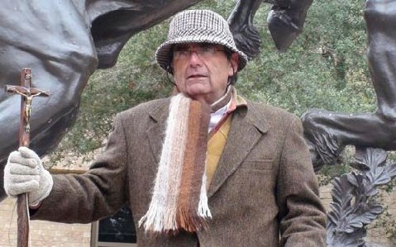
"...I wore six layers of clothes.."
About 1 PM three protestors carrying signs opposing us arrived. I was somewhat surprised that they showed up in the cold. I was also flabbergasted that a number of students stood by for over an hour to listen or argue. As Texans, the weather must have seemed even colder to them than it was to us. However, we usually do not get the strong Texas winds up North. Perhaps I should not be so amazed. What do people do when it is cold? They seek a fire. We put out more heat than any furnace on campus.
I had a profitable hour of preaching and interacting with the students. Despite there being no classes in session and there was little traffic flow, we maintained a crowd from 10-25 for the two and one half hours we preached.
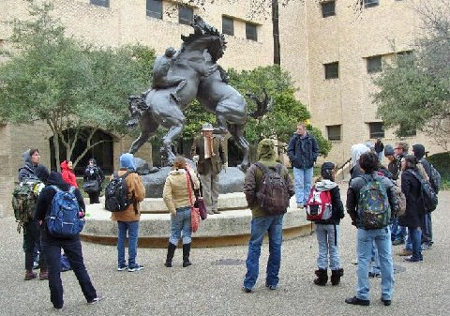
"...I was also flabbergasted that a number of students stood by for over an hour to listen or argue..."

When our gathering got down to two people plus the three protestors, I suggested to Jesse that we call it a day. Jesse had an almost five hour drive back to Tyler, TX. He is planning on working the Super Bowl in Dallas this weekend with Ruben and his crew. Also, I had had enough of the freeze. As I dismissed the students I was touched when a girl holding a protest sign asked me about my health. She evidently had read Cindy’s posts on facebook that Martha and I have been under the weather.
I cannot recall being in such a cold preach in my decades on campus. In my scheduling I try to avoid cold and I am always in search of the sun and warmer weather. But each year I usually get in at least one bad weather situation, but this is one of the worse that I remember that lasted for over a stretch of days. It is supposed to be even colder tomorrow. Martha stayed in the hotel with Mrs. Morrell and the baby, but she is planning on going out tomorrow. Hopefully, classes will be in session.
Jesse said as we were leaving campus, “You really shamed that girl who had been baptized.” In the last year or so this is a helpful course that I take. I will ask students, who deny the Lord, if they have ever been baptized or confirmed. If they say yes as they often do especially in a state like Texas, I will ask them about when and where. I will then remind them that they would have to had have made a profession of faith and confession of sin and commitment to the Lord before a congregation. I then inquire, “Are you a person who does not usually keep your word and your commitments? How could anyone trust you?” Their only defense is their youth. Of course, with most of them the confession was only from 5 to 7 years ago. They will likely use their youth many times in the future for not keeping other commitments, like wedding vows or promises to pay back loaned money, etc.
In the evening Gabe H. took Martha and me to Luby’s for dinner. Gabe was influenced by my ministry when he was a student at Texas State. He told how he is in a small church group that meets regularly. Recently, the question was raised if a Christian could live above sin. Gabe defended holiness and he was taken aback at the hostility he received. When he was an undergraduate, he was in a Christian fraternity. And he constantly had to defend my ministry to his brothers. When we parted, Gabe gave me a generous offering. It is especially meaningful to me when a student who heard me in his college day enters the business or professional world and becomes a financial supporter of the ministry. Words are encouraging, offerings enable me to stay on the road and pay the bills back home.

REMEMBER THE ALAMO!

Texas State University, February 3, 2011

The cold weather continued today with a strong wind. Morning classes were cancelled on account of an energy shortage. Martha and I arrived on campus in time to preach at the first break from 12:15-12:30. I noticed that there were many empty spaces in the parking garage so I figured there would not be a lot of students. The temperature was in the low twenties. The break was nothing comparable to other days. A few shouted obscenities and others make vulgar gestures, but today it was just too cold to get an audience. We went to the LBJ Student Center hoping perhaps to get some conversation going but hardly anyone was in the food court.
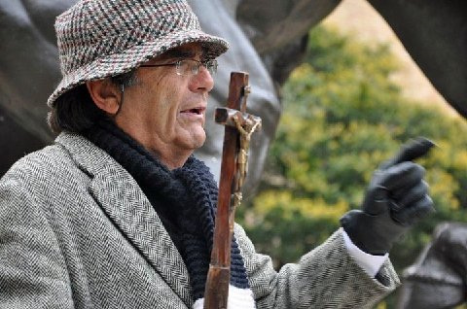
"The temperature was in the low twenties."
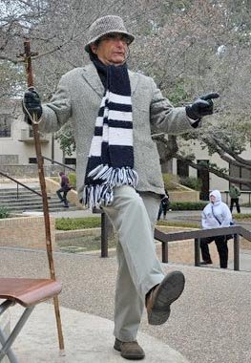

I decided to take Martha to the Alamo, which is my favorite shrine. The patron saint of the mission is St. Anthony. Upon entering the Alamo men are required to take off their hats. The last time I visited there was a moving lecture. Since attendance was small today on account of the weather, there was no lecture.
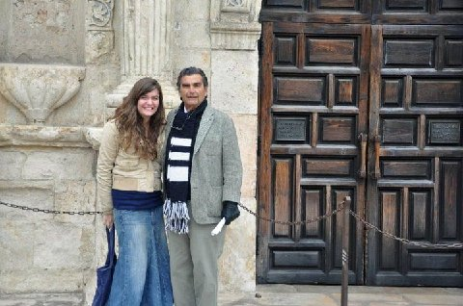
Martha and Bro. Jed at the Alamo
Crockett, Bowie, Bonham and Travis and the other defenders of the Alamo are great American heroes. On February 24, 1836, during Santa Anna's siege of the Alamo, Colonel William Travis wrote a letter addressed "To the People of Texas and All Americans in the World":
Fellow citizens and compatriots;
I am besieged, by a thousand or more of the Mexicans under Santa Anna. I have sustained a continual Bombardment and cannonade for 24 hours and have not lost a man. The enemy has demanded a surrender at discretion, otherwise, the garrison are to be put to the sword, if the fort is taken. I have answered the demand with a cannon shot, and our flag still waves proudly from the walls. I shall never surrender or retreat. Then, I call on you in the name of Liberty, of patriotism & everything dear to the American character, to come to our aid, with all dispatch. The enemy is receiving reinforcements daily and will no doubt increase to three or four thousand in four or five days. If this call is neglected, I am determined to sustain myself as long as possible and die like a soldier who never forgets what is due to his own honor & that of his country. Victory or Death.
William Barret Travis
Lt. Col. Comdt.
P.S. The Lord is on our side. When the enemy appeared in sight we had not three bushels of corn. We have since found in deserted houses 80 or 90 bushels and got into the walls 20 or 30 head of Beeves.
Travis
Travis did not get the help he requested. On March 4, knowing that their situation was hopeless, he gathered the troops and said, "We must die. Our business is not to make a fruitless effort to save our lives, but to choose the manner of our death." Then he made a sweep with his sword and drew a line in the sand, asking all who would stay to cross it and those not willing not to cross it and leave without shame. Bowie sick with Typhoid and confined to a cot asked to be carried across the line as all the men crossed except for one Frenchman, who wanted to live to fight another day. By the early morning of March 6th all the defenders of the Alamo were dead. But in death they were more than conquerors. I love those brave defenders of the Alamo and count them my friends. “Greater love hath no man than this, that a man lay down his life for his friends.”
Oh Lord, raise up preachers with commitment of the Alamo defenders for your great cause to evangelize the world and conquer for Christ. Our mission seems so small and we are surrounded by enemies of the gospel. The Santa Anna’s of the world would silence the church. Many have already surrendered to the lusts of the flesh. Never let us sound retreat but move forward storming the gates of hell. May the Word of the Lord prevail; and if we must die, let us die. Let all who fire the cannon reckon ourselves to be dead to sin and alive unto righteousness. We must prevail. Yea, with your help we shall prevail. We have nothing to fear, except the Almighty. We will be victorious over sin, death, the grave and hell. Let us never look back but let us press on to the goal of the high calling of God in Christ Jesus in whose name I pray, Amen.
February 4, 2011, Both UT and TSU closed on account of winter storm
Thank you for your faithful prayers and support. Please continue to pray for us. You may donate to CMUSA using PayPal by going to our web site brojed.org or by mailing your check to our home address: CMUSA 2402 Longview Dr. Columbia, MO 65203. All gifts are tax deductible. Thank you for your generosity.

